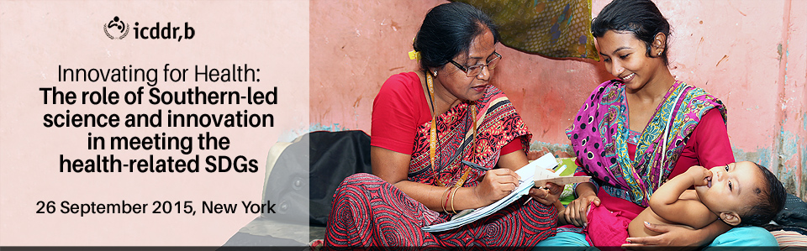

14:00 – 15:30 Embassy room,

Westin Grand Central, 212 E42nd St

Please join leading Southern scientists and supporters of Southern-led innovation for an interactive discussion about the key opportunities and challenges facing Southern-led science and innovation.  Discussion topics will include:

* The role that Southern innovators must play in achieving the Health Development Goals
* The role that Southern researchers can play in identifying local challenges and appropriate solutions
* The Infrastructure and financing mechanisms required to ensure successful outcomes
* Models of capacity building that have proven most effective to date
* How to ensure that successful intervention are effectively disseminated and brought to scale

These issues will be addressed by a moderated panel discussion consisting of:

* **Allan Pamba** (moderator), VP of Pharmaceuticals, East Africa and Government Affairs, GlaxoSmithKline Africa, and Co-Chair, Innovations Working Group
* **Priya Agrawal**, Executive Director, Merck for Mothers
* **Nicole Bates**, Deputy Director, Global Policy & Advocacy, Bill & Melinda Gates Foundation
* **Santorino Data**, Uganda Country Director, Consortium for Affordable Medical Technologies, and Lecturer, Mbarara University of Science and Technology
* **Firdausi Qadri**, Director, Vaccines Sciences, icddr,b, and Member, UN High-Level Technology Bank for Least Developed Countries
* **Peter Singer**, Chief Executive Officer, Grand Challenges Canada, and Co-Chair, Innovations Working Group
* **Teresa Soop**, Research Advisor, Department for Partnership and Innovation, Swedish Development Agency (Sida)

**Please RSVP by September 23, 2015 to** [**Gladys@icddrb.org**](mailto:Gladys@icddrb.org) **- Space is limited**

icddr,b (International Centre for Diarrhoeal Disease Research, Bangladesh) is an international public health research institution located in Dhaka. Dedicated to saving lives through research and treatment, icddr,b addresses some of the most critical health concerns facing the world today, ranging from improving neonatal survival to HIV/AIDS. In collaboration with academic and research institutions throughout the world, icddr,b conducts research, training and extension activities, as well as programme-based activities, to develop and share knowledge for global lifesaving solutions.